- Load the 'tips' dataset from Seaborn and create a pairplot to quickly visualize relationships between all numeric variables.
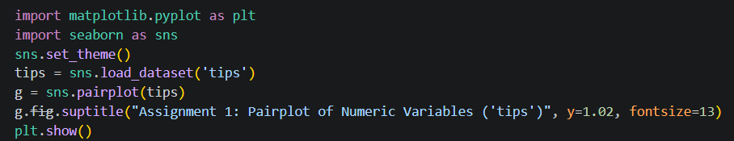
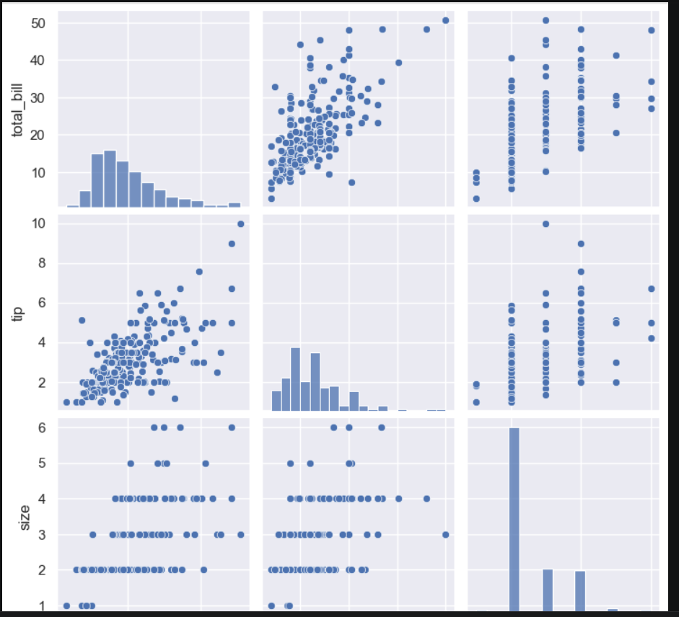

- Using the 'flights' dataset from Seaborn, generate a heatmap showing the correlation between months and years based on the number of passengers. Use pivot_table to reshape the data before plotting the heatmap.
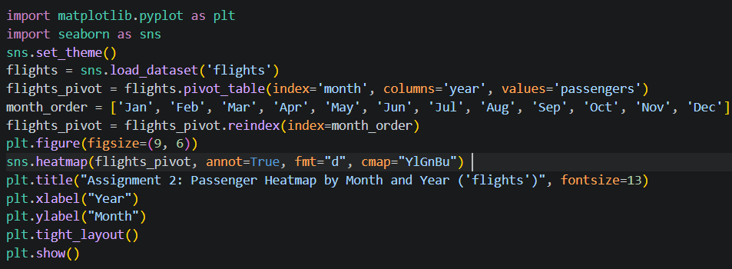
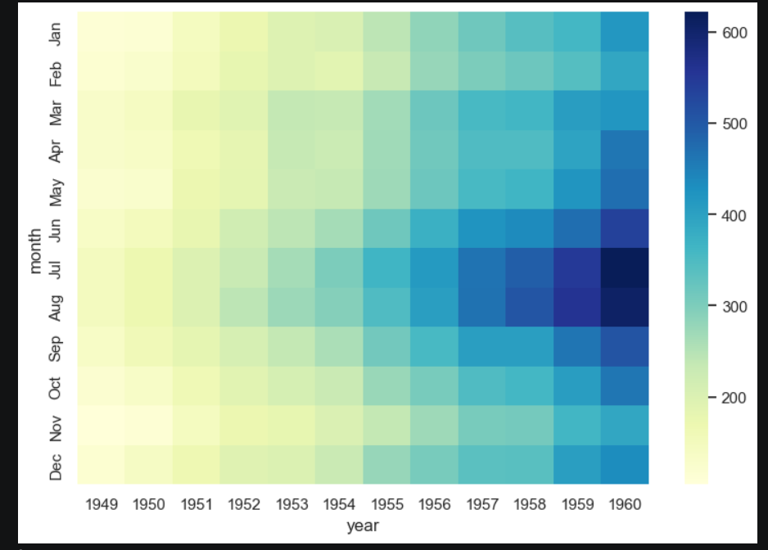

- Create a relplot using the 'fmri' dataset from Seaborn to visualize how the signal changes over time for different event types.
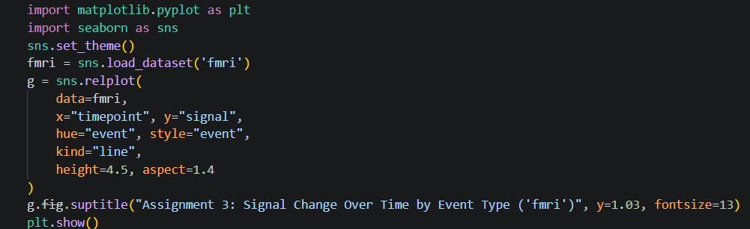
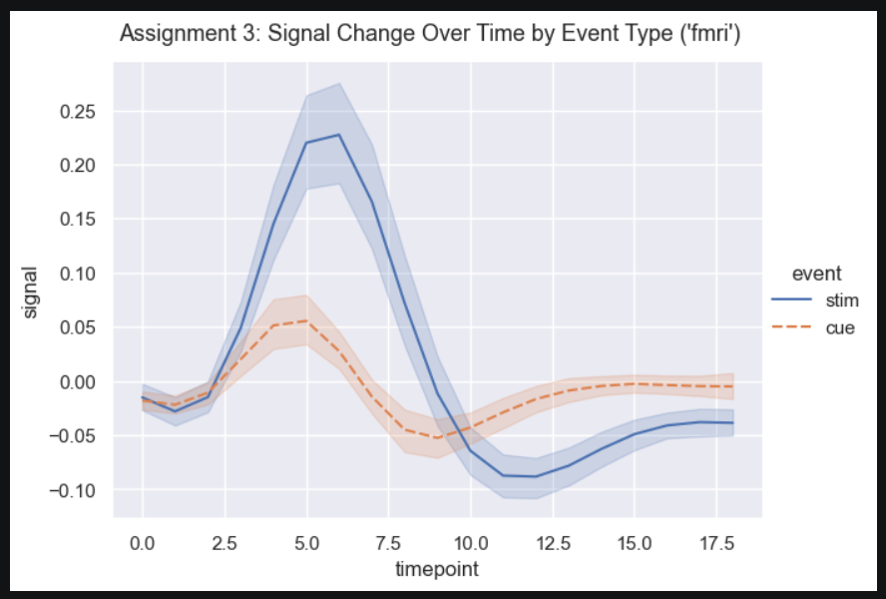

- Pick any categorical column from the 'titanic' dataset (like 'class' or 'sex') and use catplot to display the survival rate for each group with confidence intervals.
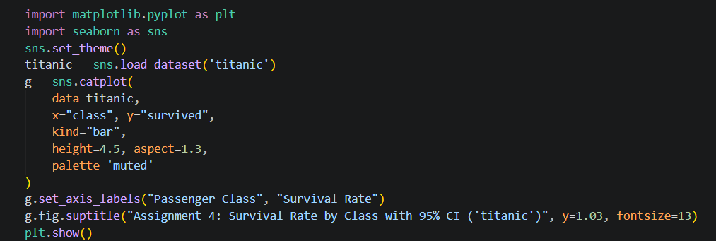
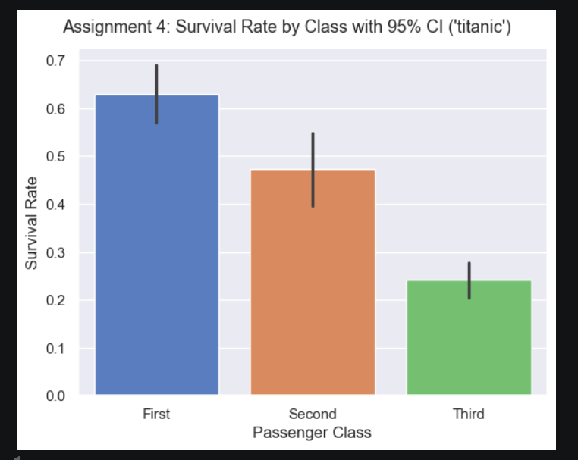
- Use jointplot on the 'penguins' dataset to visualize the relationship between bill_length_mm and flipper_length_mm, and fit a regression line on the scatter plot. Set kind='reg' in jointplot for regression line.
